6
PERFORM IP SLA FOR FOLLOWING TOPOLOGY
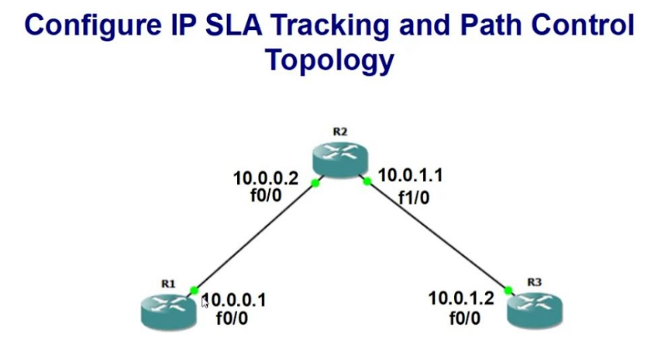

ROUTER 1 CONFIGURATION
- Configure terminal
- Interface fastEthernet 0/0
- Ip address 10.0.0.1 255.255.255.0
- no shutdown
- exit
SET ROUTING PROTOCOL
- router rip
- version 2
- network 10.0.0.0
- exit
CONFIGURING SLA
- ip sla 1
- icmp-echo 10.0.1.2 //(send echo messages to this ip address)
- timeout 1000
- frequency 3
- exit
- ip sla schedule 1 life forever start-time now
- track 1 ip sla 1 reachability
- exit
SET UP DEFAULT ROUTE
- ip route 0.0.0.0 0.0.0.0 10.0.0.2 track 1
- ip route 0.0.0.0 0.0.0.0 10.0.1.2 10
- exit

ROUTER 2 CONFIGURATION
- Configure terminal
- Interface fastEthernet 0/0
- Ip address 10.0.0.2 255.255.255.0
- no shutdown
- exit
- interface fastethernet 1/0
- ip address 10.0.1.1 255.255.255.0
- no shutdown
- exit

SET ROUTING PROTOCOL
- router rip
- version 2
- network 10.0.0.0
- network 10.0.1.0
- exit
ROUTER 3 CONFIGURATION
- Configure terminal
- Interface fastEthernet 0/0
- Ip address 10.0.1.2 255.255.255.0
- no shutdown
- exit
SET ROUTING PROTOCOL
- router rip
- version 2
- network 10.0.1.0
- exit
TO CHECK CONNECTION FROM R1

- show ip route
- show track
- show ip sla sta
- ping 10.0.0.2

